
AI Engineering/Software Engineering
Untasked: Development & Deployment
Created By:
Dávila Naveda, Luis Tomás
Lima, Peru
2026

- Create the virtual environment:
py -m venv env
.\env\Scripts\Activate.ps1

- Install django, the PostgreSQL adapter and python-dotenv library:
pip install django
pip install psycopg2-binary
pip install python-dotenv

Note: The python-dotenv library allows Django to read confidential data from a local file in a clean, automatic and secure way.
- Create a .gitignore file in the root carpet and ignore the following folder and files:
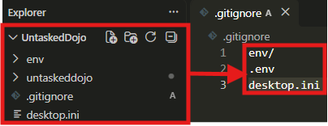
- Create the django project:
django-admin startproject untaskedproject

- Create the django apps (untaskedapp and users):
py manage.py startapp untaskedapp
py manage.py startapp users

- Create the .env file:
SECRET_KEY=our_secret_key
DEBUG=True
DB_NAME=
DB_USER=
DB_PASSWORD=
DB_HOST=
DB_PORT=

- In the settings.py file, load and use the environment variables found in the .env file:
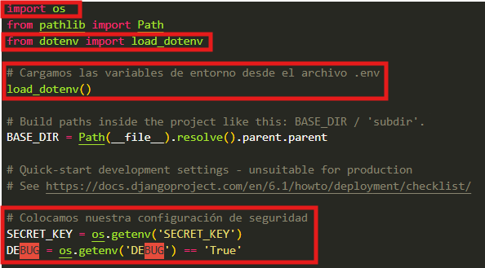
- Register the apps and connect to the database in the settings.py file:
INSTALLED_APPS = [
'django.contrib.admin',
'django.contrib.auth',
'django.contrib.contenttypes',
'django.contrib.sessions',
'django.contrib.messages',
'django.contrib.staticfiles',
'apps.users.apps.UsersConfig',
'apps.untaskedapp.apps.UntaskedappConfig',
]

DATABASES = {
'default': {
'ENGINE': 'django.db.backends.postgresql,
'NAME': os.getenv('DB_NAME'),
'USER': os.getenv('DB_USER'),
'PASSWORD': os.getenv('DB_PASSWORD'),
'HOST': os.getenv('DB_HOST'),
'PORT': os.getenv('DB_PORT'),
}
}

- Let’s create our own custom user model and user manager:
# users/models.py
from django.db import models
from django.contrib.auth.models import BaseUserManager, AbstractUser

class UsuarioManager(BaseUserManager):

def create_user(self, email, username, password, **extra_fields):
.
.
.

def create_superuser(self, email, username, password, **extra_fields):
.
.
.

class Usuario(AbstractUser):
.
.
.

- Let’s register our custom user model in the admin dashboard:
from .models import Usuario
from django.contrib import admin
from django.contrib.auth.admin import UserAdmin
@admin.register(Usuario)
class UsuarioAdmin(UserAdmin):
.
.
.

- Register the custom user model in settings.py:
AUTH_USER_MODEL = 'apps.users.Usuario'

- Let’s create our login/signup forms:
# users/forms.py
from django import forms
from .models import Usuario
from django.contrib.auth.forms import UserCreationForm, AuthenticationForm

class RegistroUsuarioForm(UserCreationForm):
class Meta:
.
.
.

def __init__(self, *args, **kwargs):
.
.
.

class LoginUsuarioForm(AuthenticationForm):
username = forms.EmailField(
label='Correo electrónico',
widget= forms.EmailInput(attrs={
'class':'form-control',
'placeholder':'correo@ejemplo.com'
})
)
password = forms.CharField(
label='Contraseña',
widget= forms.PasswordInput(attrs={
'class':'form-control',
'placeholder':'*****'
})
)
- Let’s create our authentication views:
# users/views.py
from django.urls import reverse_lazy
from django.views.generic import CreateView
from django.contrib.auth.views import LoginView
from .forms import RegistroUsuarioForm, LoginUsuarioForm

class RegistroUsuarioView(CreateView):
form_class = RegistroUsuarioForm
template_name = 'users/signup.html'
success_url = reverse_lazy('login')

class LoginUsuarioView(LoginView):
form_class = LoginUsuarioForm
template_name = 'users/login.html'
# success_url = reverse_lazy('login')
# Debido a que definimos LOGIN_REDIRECT_URL en settings.py,
# no necesitamos definir success_url.

- Define the local URLs:
# users/urls.py
from django.urls import path
from django.contrib.auth.views import LogoutView
from .views import RegistroUsuarioView, LoginUsuarioView

urlpatterns = [
path('signup/', RegistroUsuarioView.as_view(), name='signup'),
path('login/', LoginUsuarioView.as_view(), name='login'),
path('logout/', LogoutView.as_view(), name='logout')
# Debido a que definimos LOGOUT_REDIRECT_URL en settings.py,
# no necesitamos definir LogoutView.as_view(next_page=)

]

- Define the global URLs:
# untaskedproject/urls.py
from django.contrib import admin
from django.urls import path, include

urlpatterns = [
path('admin/', admin.site.urls),
path('auth/', include('apps.users.urls')),
]

- Define the following constant variables in settings.py:
LOGIN_REDIRECT_URL = 'login'
LOGOUT_REDIRECT_URL = 'logout'
LOGIN_URL = 'login'

- Create the authentication templates:
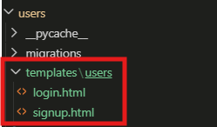
- Create the static files:
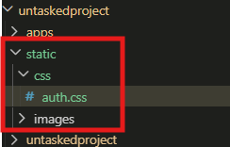
- Run the server to test the signup/login:

